Sprint 2 - Accuracy Design Document

December 7, 2020

Table of Contents
1. Executive Summary 3
1.1 Project Overview 3
1.2 Purpose and Scope of this Specification 3
2. Product/Service Description 3
2.1 Product Context 3
2.2 User Characteristics 3
2.3 Assumptions 3
2.4 Constraints 3
2.5 Dependencies 4
3. Requirements 4
3.1 Functional Requirements 5
3.2 Security 5
3.2.1 Protection 5
3.2.2 Authorization and Authentication 6
3.3 Portability 6
4. Requirements Confirmation/Stakeholder sign-off 6
5. System Design 6
5.1 Algorithm 6
5.2 System Flow 6
5.3 Software 6
5.4 Hardware 6
5.5 Test Plan 7
5.6 Task List/Gantt Chart 7
5.7 Staffing Plan 7

Executive Summary

Project Overview
The Sphero robot should follow the Robotics Triathlon figure eight course located in HH208. The robot begins in the square provided and proceeds to remain in the path while running it five times until it completes the course. Once it reaches its final destination the robot will flash multicolored light for 5 seconds and state, “I am the winner.”

Purpose and Scope of this Specification

In scope
- Audience – New Programmers
- Purpose – The software is designed to run over certain smooth surfaces.

Out of Scope
- The robot will not run on sand.
- The robot cannot recover its path if derailed from the course.
- The robot is not programmed to run a course that is not a figure eight.

Product/Service Description

Product Context
The robot endurance project is designed to go around the room and follow the figure eight course located in HH208. This product is designed to entertain children.

User Characteristics

Faculty/Staff
- Experience: Established background experience
- Technical expertise: Established background working with computers and software programs.
- Other: Knowledgeable with different computer programming languages.
College Student
- Experience: Minimal experience - none.
- Technical experience: Has previously taken a computer science course
- Other: Does not have a fundamental understanding of any computer programming language.

Assumptions
- Sphero SPRK robot is required

- Basic understanding of programming in order to use application

Constraints
- Forced to work in virtually due to COVID-19

- Difficult schedules to line up meeting arrangements

Dependencies
- A group member must be on campus to pick up a robot
- Room HH208 is necessary to use in order to run the program
- Sphero Edu application is needed to create code for robot
- Wi-Fi connection for group meetings and project creation

Requirements

Functional Requirements

Req# | Requirement | Comments | Priority | Date Rvwd | SME Reviewed / Approved
ENDUR_01 | Start on Yellow Square, Run figure 8 course, 1 time, finish on square. | Successful | 1st | 11/24 | 11/24
ENDUR_02 | Maintain the robot in the path | Required multiple tries, but was successful | 2nd | 11/24 | 11/24
ENDUR_03 | Loop Path and run figure 8 course 5 times | Successful | 3rd | 11/24 | 11/24
ENDUR_04 | Maintain the path through 5 times | Successful | 4th | 11/24 | 11/24
ENDUR_05 | Finish at yellow square | Successful | 5th | 11/24 | 11/24
ENDUR_06 | Speak ‘I am the winner’ | Successful | 6th | 11/24 | 11/24

Security

Protection

The factor that will protect the system from malicious or accidental access, modification, disclosure, destruction, or misuse encryption is by backing up our program into the cloud.

Authorization and Authentication
An account is created for Sphero so a password is required in order to view the code. A members only GitHub repository is created to secure access to the program.

Portability
- The code can be accessed through any operating system that has Wifi connection and the robot.

- Block code is a beginner's programming language which makes it easy understandable to anyone.

Requirements Confirmation/Stakeholder sign-off

Meeting Date | Attendees (name and role) | Comments
11/24/20 | Alicia Sanchez, Michael Mendoza, Carlos Navarro | Confirmed all

System Design
This section will provide all details concerning the technical design, staffing, coding, and testing the system

Algorithm

- Start at yellow square
- Run course 1 time
- Maintain inside the path
- Loop path run for 4 more times
- Finish at yellow square
- Speak “I am the winner”

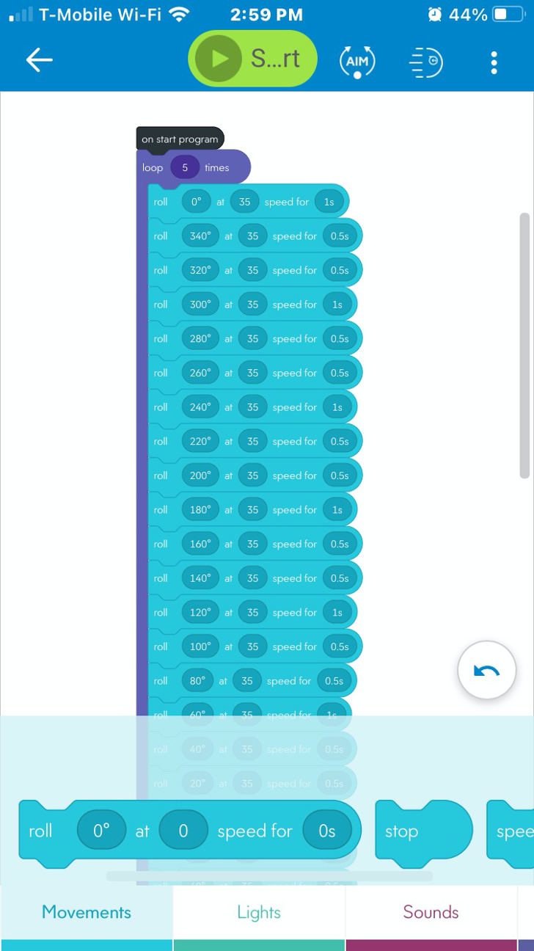

System Flow

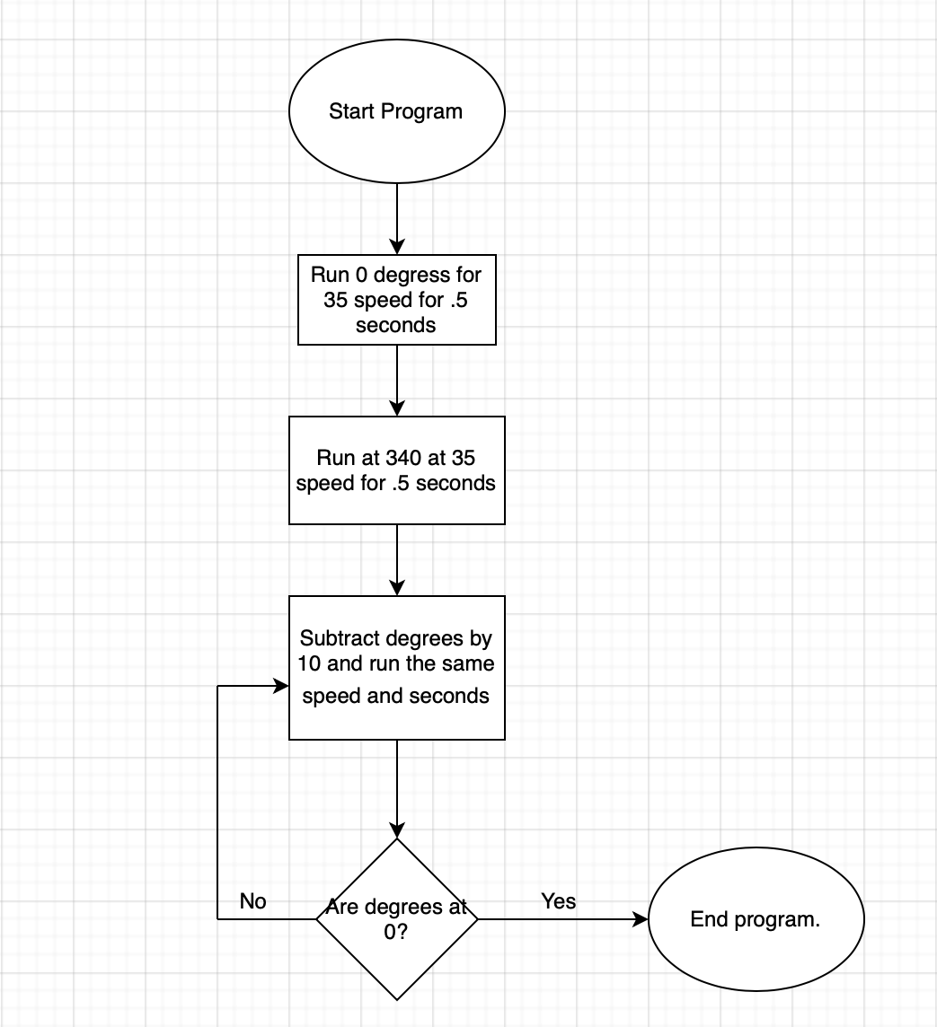

Software

Sphero robots can be programmed with easy drag-and-drop blocks or text-based code.Intermediate coders can utilize the familiar block-based drag-and-drop interface. Pre-programmed blocks allow for a wide variety of actions and variables.

Hardware

The only hardware that is absolutely necessary is the robot itself and a device that supports the Sphero Edu app. The testing took place in room HH208, but with creativity the same ‘obstacle’ course can be recreated anywhere.

Test Plan

Reason for Test Case | Test Date | Expected Output | Observed Output | Staff Name | Pass/Fail
Program the robot to run the course | 11/24 | Robot will run through figure eight course | Did not stay in the path | Michael Mendoza | Fail
Adjust Speed/distance | 11/24 | Adjusted program will run the path | Maintained the path | Michael Mendoza | Pass
Loop the program 4 times | 11/24 | Program will run total of 5 times | Speed/Degrees did not run inside path all four times | Michael Mendoza | Fail
Loop the program 4 times attempt 2 | 11/24 | Adjusted program will run effectively | Did not run effectively | Michael Mendoza | Fail
Loop program 4 times attempt 3 | 11/24 | Adjust to run the path | Ran the path effectively | Michael Mendoza | Pass
Finish at yellow square | 11/24 | The program will finish on the yellow square | Adjusted distance allowed for robot to finish at yellow square | Michael Mendoza | Pass
Speak | 11/24 | Program will speak | Spoke ‘I am the winner’ | Michael Mendoza | Pass

Task List/Gantt Chart

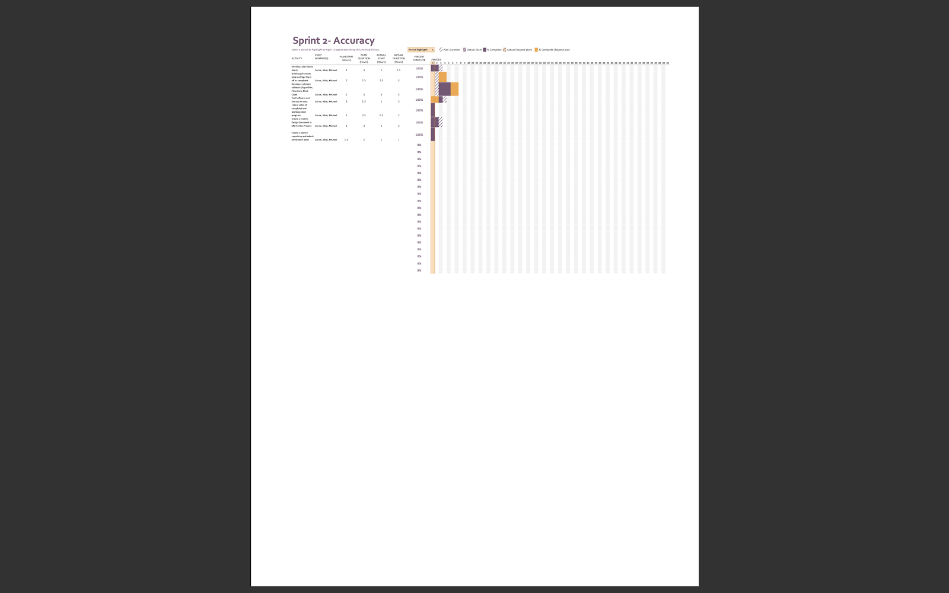

Staffing Plan

Name | Role | Responsibility | Reports To
Carlos Navarro | Planner | Organizing the role of each group member. Carlos made sure that there was clarity between group members in what each others roles were and executed his role to the best of his ability. | Michael Mendoza
Michael Mendoza | Engineer | Michael was in charge of the inner workings of the robot. He led the group in software engineering and developed a sophisticated algorithm that made the robot usable. | Alicia Sanchez
Alicia Sanchez | Organizer/ Promoter | Alicia was in charge of putting together the marketing plan for our robot. She was the voice behind our description in the System Design and organized the group members work. Her role was to make our product as desirable and marketable as possible. | Carlos Navarro

